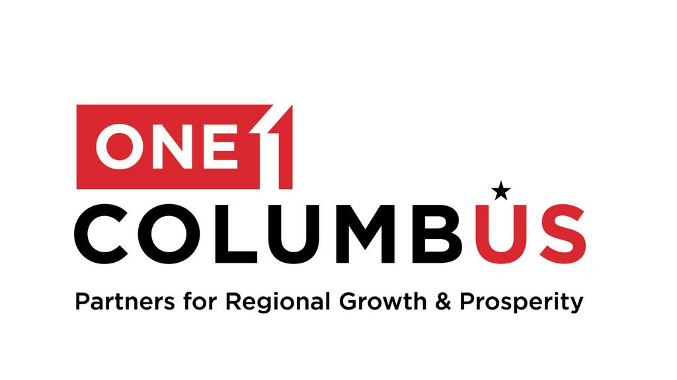

For Immediate Release  November 4, 2024 | One Columbus Media Contact  Jon Keeling  614-657-5917  jk@columbuspartnership.com
ONE COLUMBUS ANNOUNCES EXECUTIVE OFFICERS
Executives from Ohio State University, Nationwide, and AEP Ohio to Help Lead the 11-County Regional Economic Development Organization for Central Ohio

Columbus, Ohio – One Columbus is pleased to announce new appointments to its Executive Committee, welcoming three prominent leaders who will help guide the organization’s mission of advancing economic growth and innovation in the Columbus Region. Peter Mohler, Executive Vice President for Research, Innovation and Knowledge at Ohio State and Chief Scientific Officer at The Ohio State University Wexner Medical Center, will serve as Chair; Marc D. Reitter, President and Chief Operating Officer of AEP Ohio, will serve as Secretary; and Mark Berven, President and Chief Operating Officer at Nationwide Property & Casualty, has been appointed Treasurer.

“These new appointments reflect the caliber and commitment of leadership that will continue to distinguish The Columbus Region as a forward thinking, results-oriented region,” said Kenny McDonald, President and CEO of the One Columbus. “Peter, Marc, and Mark each bring invaluable experience and vision to our Executive Committee, and their leadership will help us achieve our goal of making the Columbus Region the most prosperous in the nation.”

About Peter Mohler
Peter Mohler, PhD, is Executive Vice President for Research, Innovation, and Knowledge at The Ohio State University, where he also serves as Chief Scientific Officer for the Wexner Medical Center. Since joining Ohio State in 2011, Dr. Mohler has led pioneering research into the genetics of abnormal heart rhythms and heart failure, resulting in over 280 peer-reviewed publications. An award-winning scientist and mentor, he oversees research strategy, compliance, and interdisciplinary initiatives across Ohio State’s health science enterprise. Dr. Mohler earned his PhD from the University of North Carolina at Chapel Hill and completed a fellowship at the Howard Hughes Medical Institute at Duke University Medical Center.

About Marc Reitter
Marc Reitter is President and Chief Operating Officer of AEP Ohio, where he oversees electric service for 1.5 million customers and leads over 1,500 employees in delivering reliable energy, advancing smart infrastructure, and implementing custom energy solutions. Since joining AEP in 2002, Reitter has held various leadership roles across finance, strategic initiatives, and utility business services. An Ohio native, he holds a bachelor’s degree in finance from Arizona State University and an MBA from The Ohio State University’s Fisher College of Business. He serves as board chair for Goodwill Columbus and is a board member of the Down Syndrome Association of Central Ohio, Foundation for Appalachian Ohio, One Columbus, and the Nationwide Children's Hospital Championship.

About Mark Berven
Mark Berven is President and Chief Operating Officer of Nationwide Property & Casualty, overseeing personal lines, commercial lines, excess and surplus, agribusiness, and specialty insurance. With a career at Nationwide spanning over three decades, Berven has held executive roles focused on property casualty insurance, corporate strategy, and risk management. He earned his degree from the University of Northern Colorado and holds Chartered Property Casualty Underwriter and Associate in Claims designations. Berven is active in nonprofit and industry organizations, serving on the boards of the National 4-H Council, St. John’s School of Risk Management, and One Columbus.

###
_______________________________________________________________________________________

About One Columbus
As the economic development organization for the 11-county Columbus Region, One Columbus’ mission is to lead a comprehensive regional growth strategy that develops and attracts the world’s most competitive companies, grows a highly adaptive workforce, prepares our communities for the future and inspires corporate, academic and public innovation throughout the Columbus Region. One Columbus expertly guides companies through the location decision process. Through strategic business outreach and customized research, the One Columbus team leverages public, private and institutional partnerships to grow the Columbus Region’s economy and strengthen its national and international competitiveness. Funding is received from more than 275 private organizations, local governments, academic institutions and JobsOhio. Learn more at ColumbusRegion.com.

