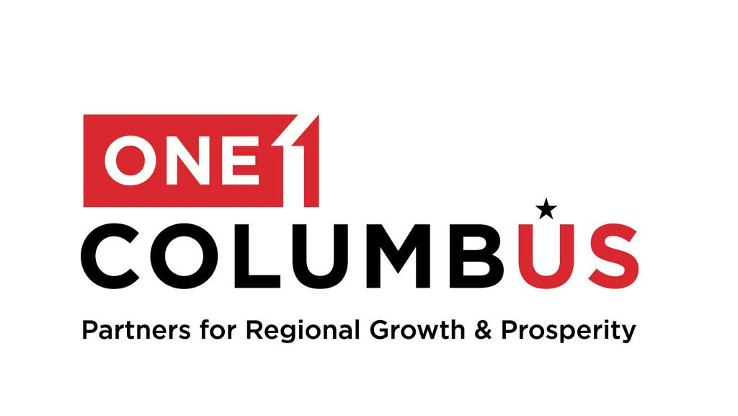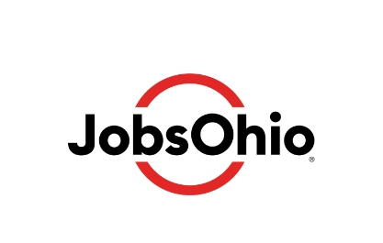

For Immediate Release  October 28, 2024 | One Columbus Media Contact  Jon Keeling  614-657-5917  jk@columbuspartnership.com
ONE COLUMBUS ANNOUNCES FIRST PHASE OF NEW DATA CENTER INVESTMENT BY MICROSOFT IN THE COLUMBUS REGION
Initial $1 Billion Investment for Three New Campuses Will Power Global Growth in Cloud Computing

Columbus, Ohio – One Columbus today announced the first phase of a major investment plan from Microsoft to establish three new data center campuses in the Columbus Region, with an initial $1 billion investment for facilities in New Albany, Heath, and Hebron. While this announcement is just the beginning, Microsoft states the project has significant growth potential for continued investment and the creation of hundreds of direct jobs if the campuses reach full capacity. Together, the three campuses will play a critical role in expanding Microsoft’s cloud infrastructure to support rapid global growth in digital services.

As cloud technology becomes more integrated into daily life and business operations, the demand for data storage, computing power, and digital infrastructure is increasing at an exponential rate. These new facilities will serve as the backbone for Microsoft Azure’s capabilities.

“We are excited to work with state, regional, and local partners to bring new datacenter campuses to the Columbus region,” said Bowen Wallace, Microsoft CVP Datacenters, Americas Region. “The Columbus Region’s skilled workforce, strong infrastructure, and strategic location make it ideal for this project. Many Ohio businesses and government entities use the Microsoft cloud as the platform for their business operations. These datacenter developments will help us continue to effectively serve our Ohio customers."

“Microsoft’s investment in these new data center campuses reflects a commitment to strengthening the communities where they will operate while building cloud infrastructure in Ohio,” said JobsOhio President and CEO J.P. Nauseef. “Beyond the economic impact, these projects will bring lasting benefits by supporting local school districts, enhancing infrastructure, and creating new career pathways for residents.”

The initial phase will establish three data center campuses as part of Microsoft’s global network of cloud computing infrastructure, which currently spans more than 60 Azure regions, 300 data centers, 280,000 kilometers of fiber, and 190 edge sites around the world. Future phases of the project have the potential to increase the size and capacity of these sites. During the construction phase of these projects, Microsoft expects as many as 400 construction jobs on an annual basis. At full build-out, these locations are expected each to employ hundreds of full-time employees with competitive wages and world-class benefits. The new campus locations in Hebron and Heath are pending local approvals.

With the addition of Microsoft’s new campuses, the Columbus Region continues to grow as a technology hub. Investments like these across the region now surpass $20 billion and are transforming our technological landscape while strengthening infrastructure, schools, and community development. Furthermore, data centers support the local economy through job creation, workforce training, and enhanced connectivity. For more on the positive impact of data centers, visit here: https://columbusregion.com/content-hub-article/the-data-center-sweepstakes/

“The City of New Albany is thrilled that Microsoft will be establishing operations in our community,” said New Albany Mayor Sloan Spalding. “Data centers are key assets to the New Albany community, allowing us to diversify the types of companies within our business portfolio. This investment not only reinforces New Albany’s reputation as a hub for innovation and technology but also represents a significant step forward in our continued efforts to attract world-class companies to our community. We are excited to welcome Microsoft and look forward to the positive impact this project will bring to the region.”

Heath Mayor Mark Johns emphasized the long-term benefits for his city: “We are excited to welcome Microsoft to Heath. Their decision to invest here not only brings an immediate economic boost but also positions our community as a vital part of the region’s digital infrastructure.”

“We are proud that Hebron has been selected as one of the sites for Microsoft’s latest investment,” said Hebron Mayor Valerie Mockus. “This project will create lasting value for our community and further demonstrate Hebron’s ability to support large-scale, cutting-edge technology projects.”

The timeline for construction and operations will depend on the design, planning, and permitting process, with each campus developed in phases in close coordination with local communities and stakeholders.

###

About JobsOhio
JobsOhio is a private nonprofit economic development corporation designed to drive job creation and new capital investment in Ohio through business attraction, retention and expansion. The organization also works to seed talent production in its targeted industries and to attract talent to Ohio through Find Your Ohio. JobsOhio works with seven regional partners across Ohio: Dayton Development Coalition, Lake to River, Ohio Southeast, One Columbus, REDI Cincinnati, Regional Growth Partnership and Team NEO. Learn more at www.jobsohio.com. Follow the company on LinkedIn, Twitter and Facebook.

About One Columbus
As the economic development organization for the 11-county Columbus Region, One Columbus’ mission is to lead a comprehensive regional growth strategy that develops and attracts the world’s most competitive companies, grows a highly adaptive workforce, prepares our communities for the future and inspires corporate, academic and public innovation throughout the Columbus Region. One Columbus expertly guides companies through the location decision process. Through strategic business outreach and customized research, the One Columbus team leverages public, private and institutional partnerships to grow the Columbus Region’s economy and strengthen its national and international competitiveness. Funding is received from more than 300 private organizations, local governments, academic institutions and JobsOhio. Learn more at ColumbusRegion.com.

