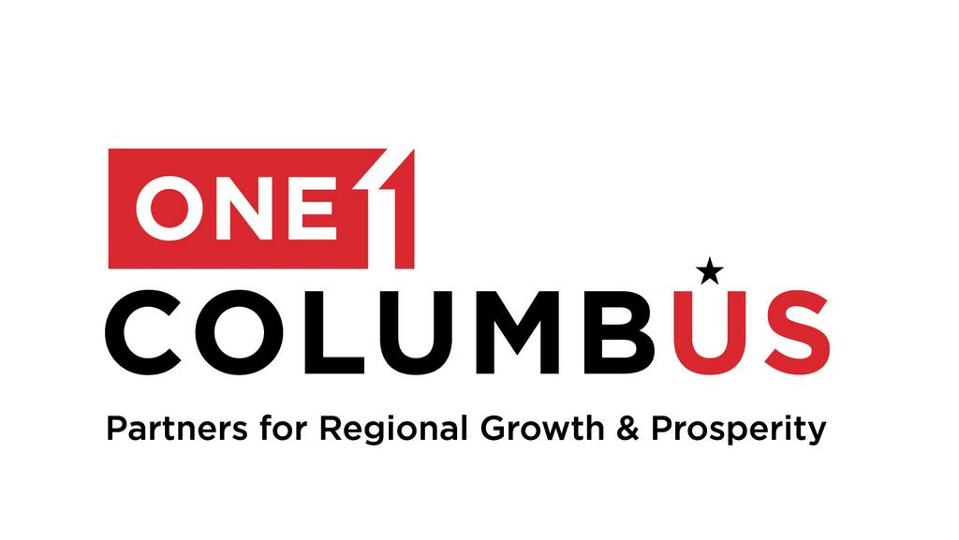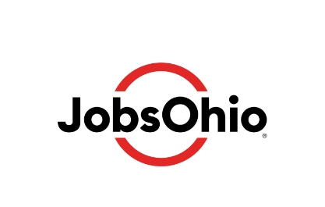

For Immediate Release  October 28, 2024 | One Columbus Media Contact  Jon Keeling  614-657-5917  jk@columbuspartnership.com
MARUSSIA BEVERAGES USA ANNOUNCES EXPANSION OF WATERSHED DISTILLERY AND ESTABLISHMENT OF U.S. HEADQUARTERS IN CENTRAL OHIO
New Investment Creates 35 New Jobs and Deepens Production Capabilities

Columbus, Ohio – Marussia Beverages USA is officially announcing a major expansion of Watershed Distillery, marking the establishment of the company’s first U.S. production facility and the relocation of its U.S. headquarters to Central Ohio. This new phase of growth will involve significant investments in infrastructure and distilling equipment. In addition to this capital expenditure, Marussia plans to hire 35 new employees while retaining its current workforce, reinforcing its commitment to the Columbus area and the Watershed brand.

“The expansion of Watershed Distillery marks an exciting new chapter for Marussia Beverages USA as we establish our new U.S. headquarters and build upon the craftsmanship and innovation that define the Watershed brand,” said John Horn, CEO of Marussia Beverages USA. “This investment will allow us to expand production, create new jobs, and deepen our roots here in Columbus. We look forward to the opportunities this next chapter will bring to both Watershed and the community.”

Since acquiring Watershed Distillery last year, Marussia Beverages USA has prioritized growth in the U.S. market, focusing on enhancing Watershed’s production of premium spirits such as American whiskey, gin, and vodka. The expansion will include production, operations, sales, marketing, and administrative roles.

"This is an exciting milestone for Watershed and the community that has supported us from the start," said Greg Lehman, founder of Watershed and Chief Operating Officer of Marussia Beverages USA. "We’re proud of the talented workforce in Central Ohio and excited to create new jobs that will expand Marussia’s U.S. presence, all from Watershed’s hometown."

“Watershed Distillery’s expansion and Marussia Beverage USA’s decision to establish their U.S. headquarters in Columbus represent a significant commitment to Ohio,” said JobsOhio President and CEO J.P. Nauseef. “This project not only adds new jobs but also strengthens Ohio’s position as a destination for premium food and beverage brands.”

Construction and equipment upgrades, as well as hiring for the new positions, are set to begin in Q1 2025, with the expanded operations expected to reach full capacity by late 2027. The project will further enhance the Columbus Region’s position as a hub for food and beverage production, driving economic growth and fostering community engagement.

###

About Marussia Beverages USA
Marussia Beverages USA is the importer and distributor of Marussia Beverages Global portfolio of premium spirits, sake, and wines in the US Market. Additionally, Marussia Beverages USA imports and distributes premium spirits and wine brands for third-party global partners.

In 2023, Marussia Beverages USA acquired Watershed Distillery, a premium, award-winning portfolio of craft brands in the American Whiskey, Gin, Vodka and Ready-To-Serve categories.

Together with Marussia Beverages brands such as Hatozaki Whiskies, Mozart Chocolate Liqueurs, Torabhaig Scotches, and Akashi Tai Sakes, we enjoy a strong, fast-growing portfolio of craft, premium brands that have rich histories and incredible people behind them.

About JobsOhio
JobsOhio is a private nonprofit economic development corporation designed to drive job creation and new capital investment in Ohio through business attraction, retention and expansion. The organization also works to seed talent production in its targeted industries and to attract talent to Ohio through Find Your Ohio. JobsOhio works with seven regional partners across Ohio: Dayton Development Coalition, Lake to River, Ohio Southeast, One Columbus, REDI Cincinnati, Regional Growth Partnership and Team NEO. Learn more at www.jobsohio.com. Follow the company on LinkedIn, Twitter and Facebook.

About One Columbus
As the economic development organization for the 11-county Columbus Region, One Columbus’ mission is to lead a comprehensive regional growth strategy that develops and attracts the world’s most competitive companies, grows a highly adaptive workforce, prepares our communities for the future and inspires corporate, academic and public innovation throughout the Columbus Region. One Columbus expertly guides companies through the location decision process. Through strategic business outreach and customized research, the One Columbus team leverages public, private and institutional partnerships to grow the Columbus Region’s economy and strengthen its national and international competitiveness. Funding is received from more than 300 private organizations, local governments, academic institutions and JobsOhio. Learn more at ColumbusRegion.com.

###

